LLM based employee sentiment detection
By: Deep Gautam Kapadia
deepgautamkapadia@gmail.com
Abstract:
This project develops an end-to-end data science pipeline to monitor and analyze employee engagement, sentiment trends, and attrition risks using unstructured text data. Recognizing that workplace communication often consists of scattered, non-work-related chatter and highly nuanced emotional tones (such as passive-aggressiveness or subtle frustration), this framework leverages a Large Language Model (LLM) approach for contextual sentiment classification, outperforming traditional dictionary-based NLP methods.
The modular architecture consists of six sequential Python scripts developed within a VS Code environment. Following advanced sentiment labeling, the pipeline performs thorough Exploratory Data Analysis (EDA) to map baseline organizational health and track communication trends over time. Text metadata is subsequently aggregated to calculate dynamic, resetting monthly sentiment scores for employee ranking, alongside a strict 30-day rolling window algorithm designed to flag immediate attrition indicators ("Flight Risks") based on acute negative communication spikes. Finally, a predictive features model utilizes message metadata (e.g., frequency and structural metrics) to evaluate and forecast sentiment velocity. The resulting ecosystem equips HR and leadership teams with reproducible, data-driven, and highly actionable insights to proactively improve employee retention and workplace culture.

Methodology and Architecture:
The project is engineered as a decoupled, modular data pipeline designed to transition raw, unstructured text data into predictive, actionable organizational insights. Operating sequentially across six dedicated Python scripts, the pipeline initiates with data ingestion and semantic classification, moves through statistical aggregation and feature engineering, and culminates in predictive modeling. Raw data from the communication logs is first processed through the sentiment engine, which appends structural labels to the text. This enriched dataset serves as the single source of truth, branching concurrently into an exploratory analytics engine that generates temporal visualizations, an aggregation module that computes resetting monthly cultural scores, and a precise rolling-window algorithm that tracks acute risk boundaries. By isolating each analytical layer into independent operational scripts, the architecture guarantees low structural coupling, allowing individual computational steps—such as shifting from an API-driven classification model to a local open-source framework—to be modified without breaking downstream analytical dependencies.

Why an LLM Was Chosen Over Traditional NLP Techniques:
Traditional Natural Language Processing (NLP) techniques, such as lexicon-based models like NLTK VADER or TextBlob, rely heavily on static dictionaries and explicit keyword matching. While highly efficient for structured, uniform text, these algorithmic approaches inherently fail when deployed against scattered corporate communication, which frequently blends casual, non-work-related banter with complex workplace context. Lexicon models evaluate words in isolation, making them fundamentally blind to semantic shifts, syntactic context, and cultural idioms. For example, a traditional NLP analyzer might misclassify a frustratingly passive-aggressive phrase like "Per my last email, thanks for finally getting to this" as entirely positive due to the presence of the word "thanks." Similarly, it would struggle to accurately gauge neutral, non-operational chatter about weekend plans, distorting the overall structural score of an employee's communication profile.
Large Language Models (LLMs) solve this critical limitation by shifting from keyword recognition to deep contextual comprehension. Built upon transformer architectures that leverage self-attention mechanisms, LLMs evaluate individual words in relation to every other word in a sentence, capturing nuanced emotional undertones, underlying frustration, and subtle sarcasm. This contextual awareness is vital for an enterprise dataset where employees rarely express dissatisfaction through obvious negative keywords, but rather through shifting syntactic patterns, changes in message length, and professional deflection. By deploying an LLM with a robust system prompt, the sentiment classification layer actively filters out non-work-related noise and decodes complex, blended tones. This provides an accurate, context-aware foundation that ensures downstream metrics—such as monthly rankings and rolling flight risk identification—are driven by true sentiment velocity rather than superficial vocabulary choices.

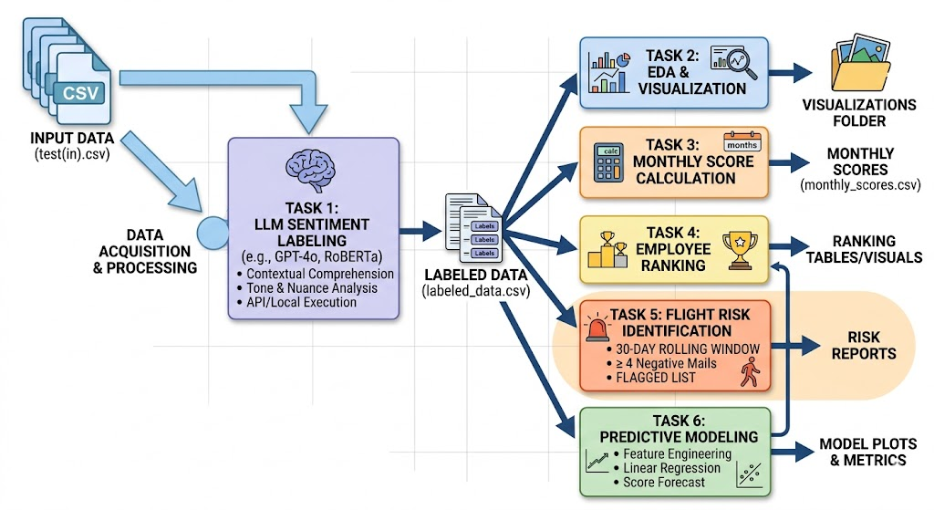

Analysis:
Here are the Employee rankings per month for the years 2010-2011:-
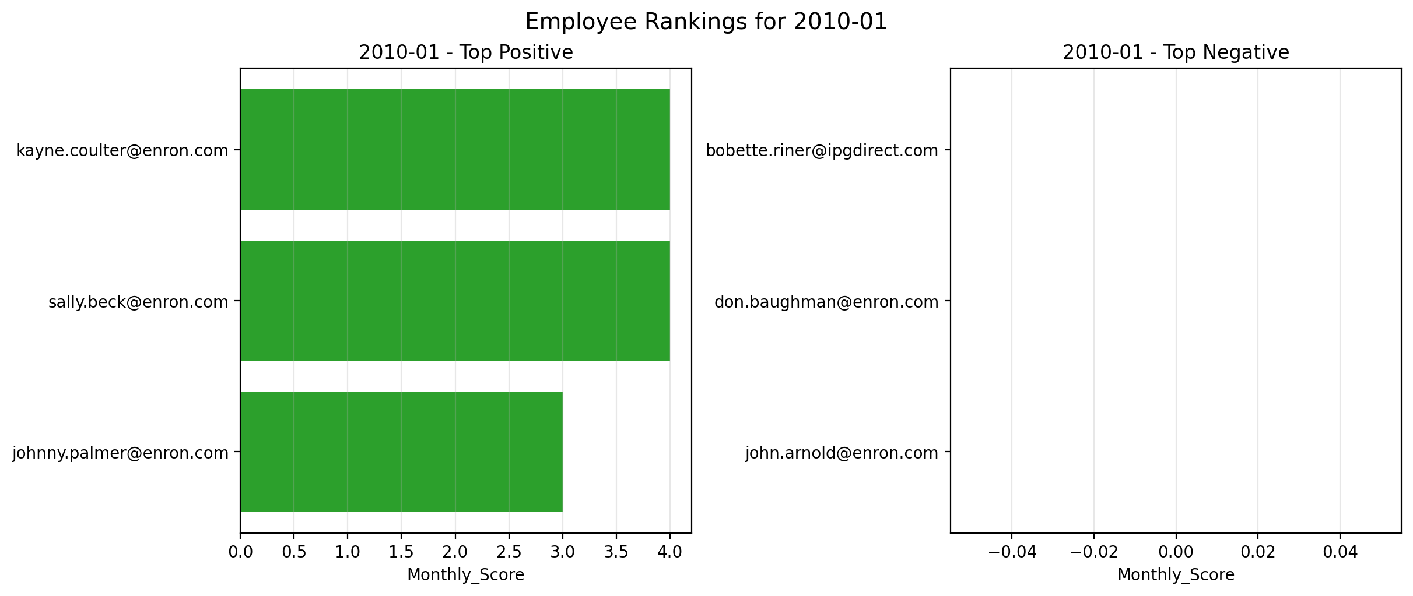
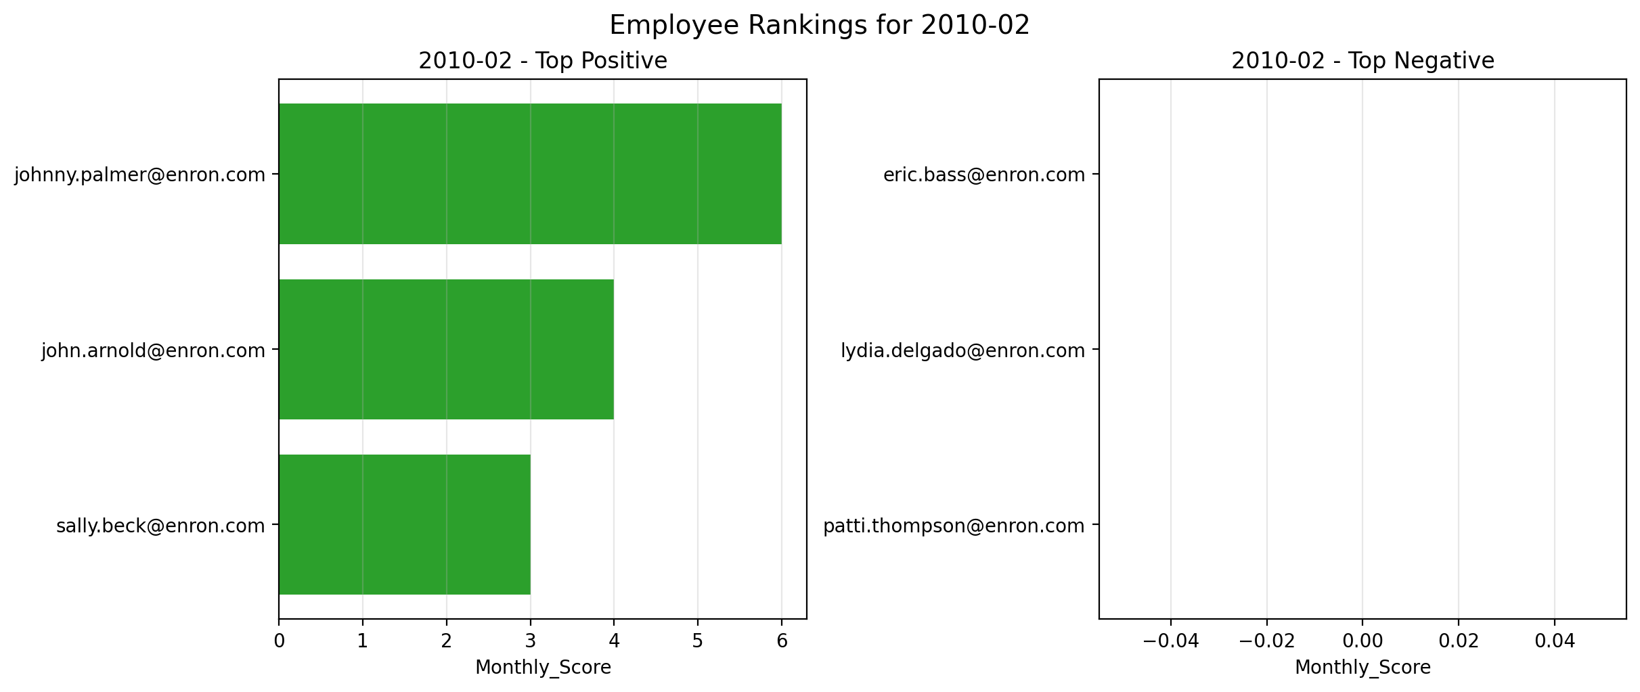
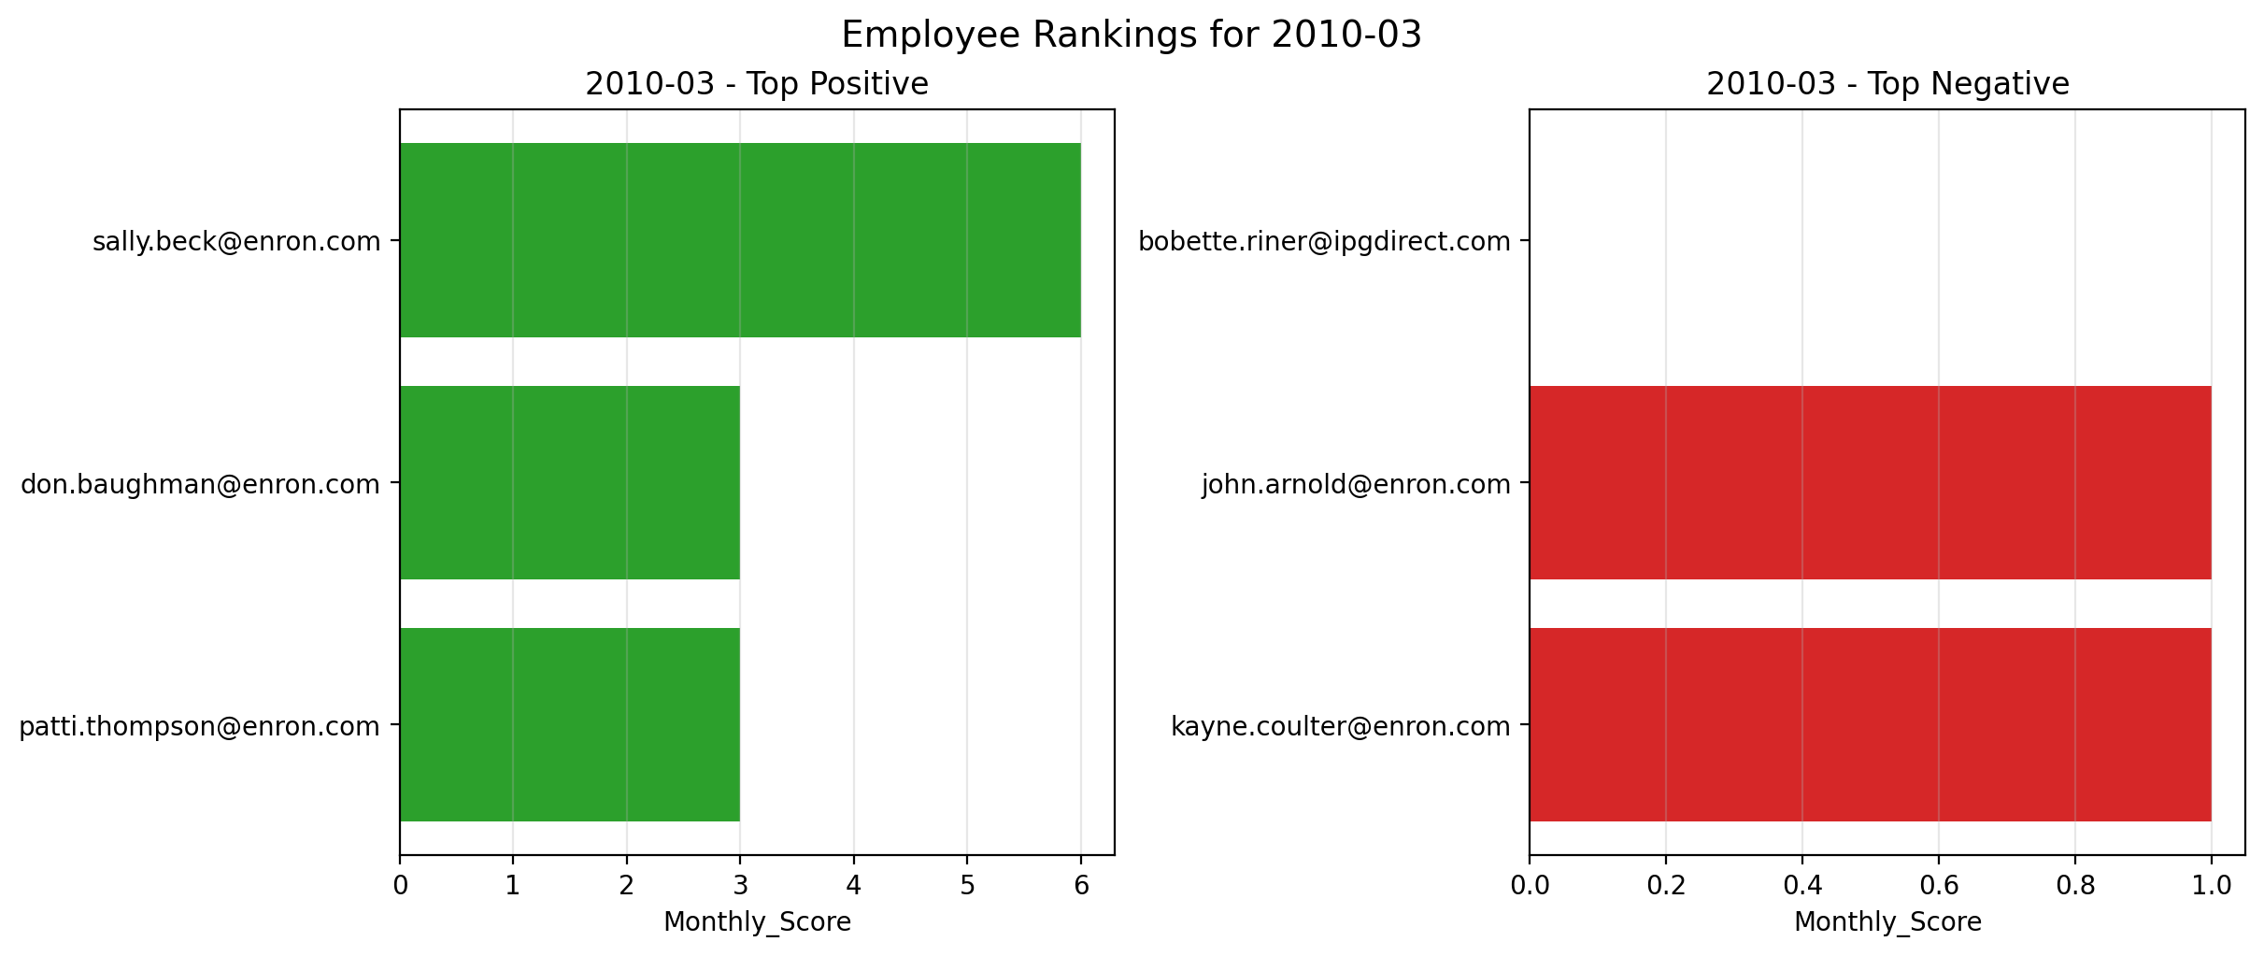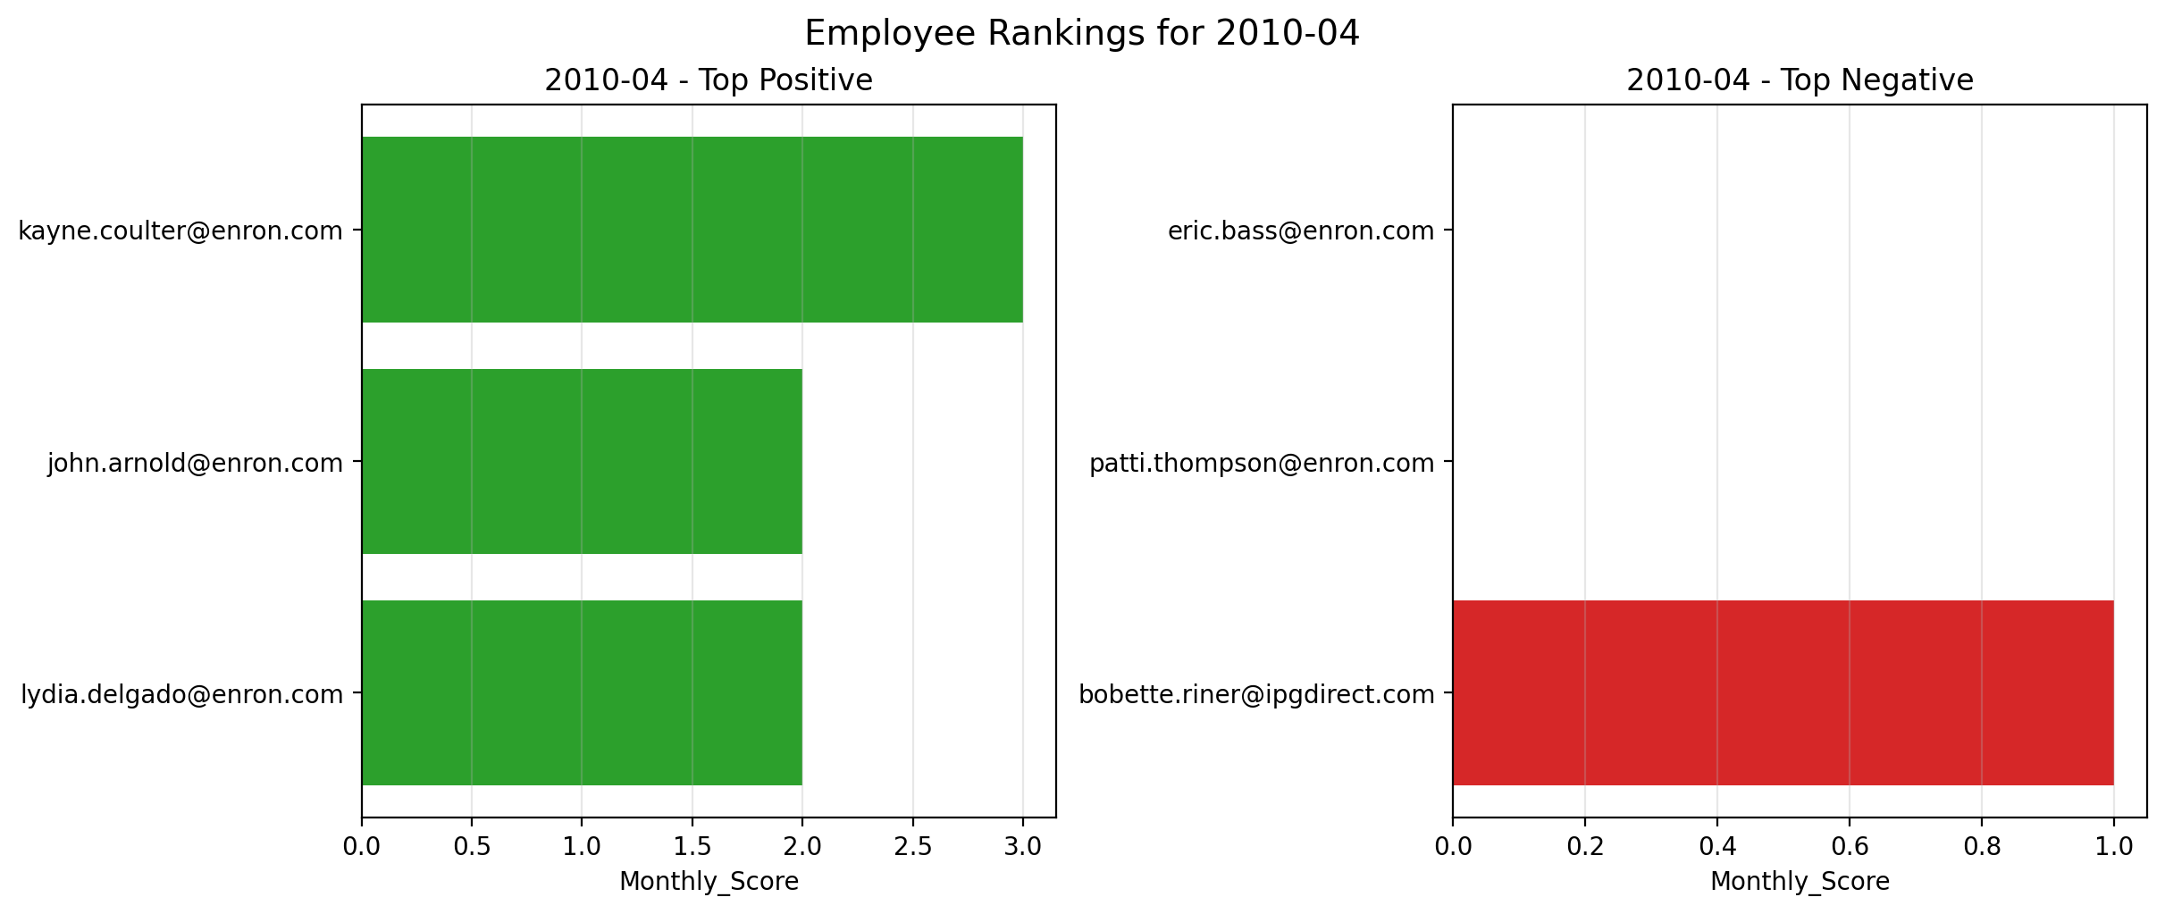
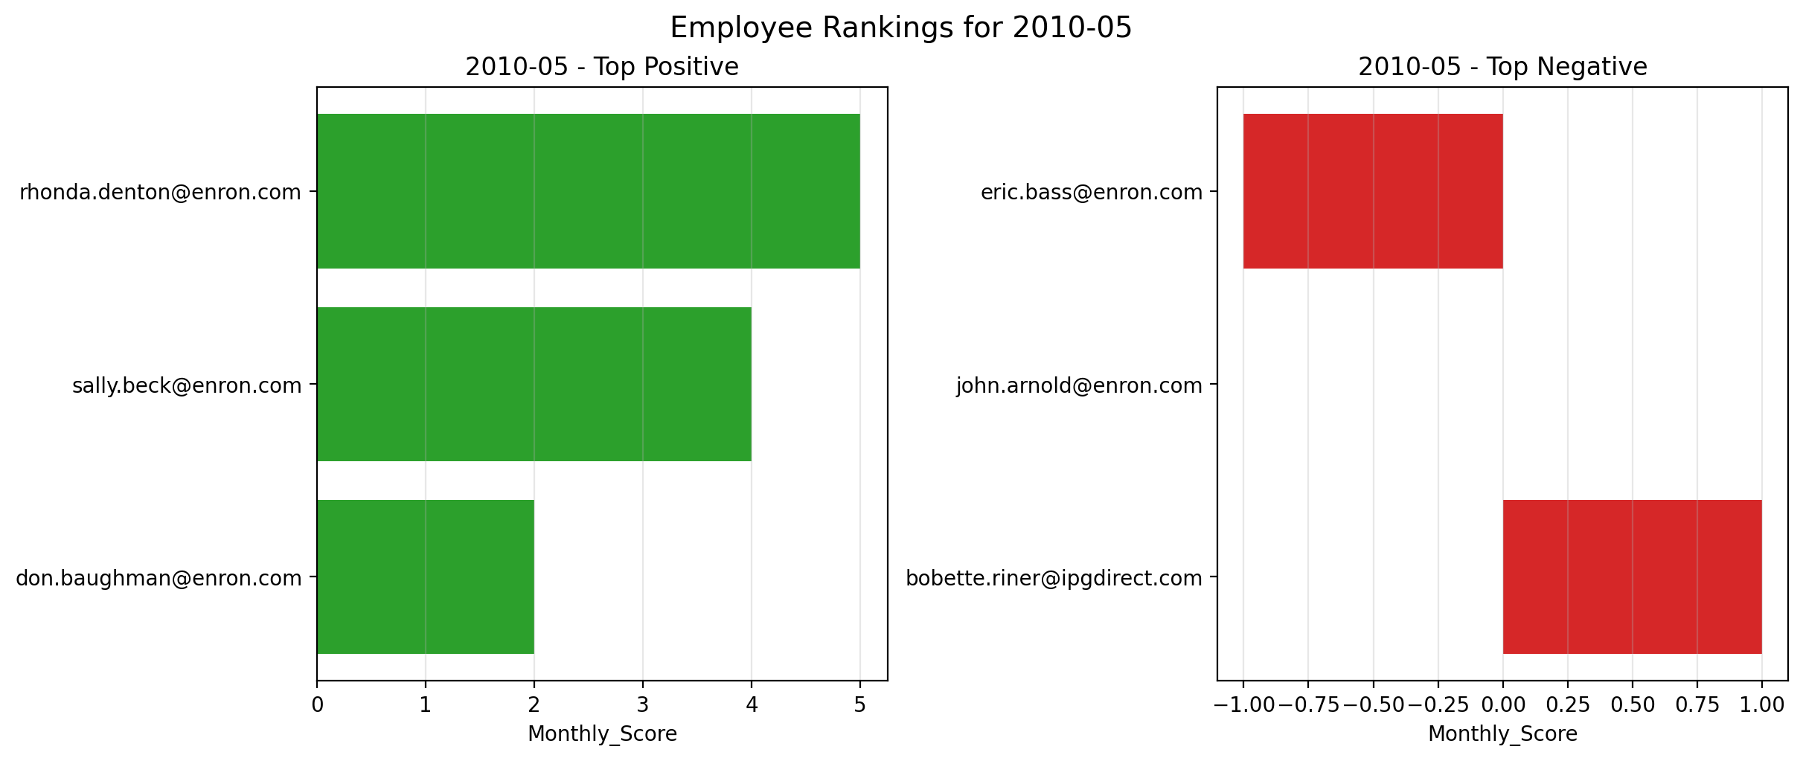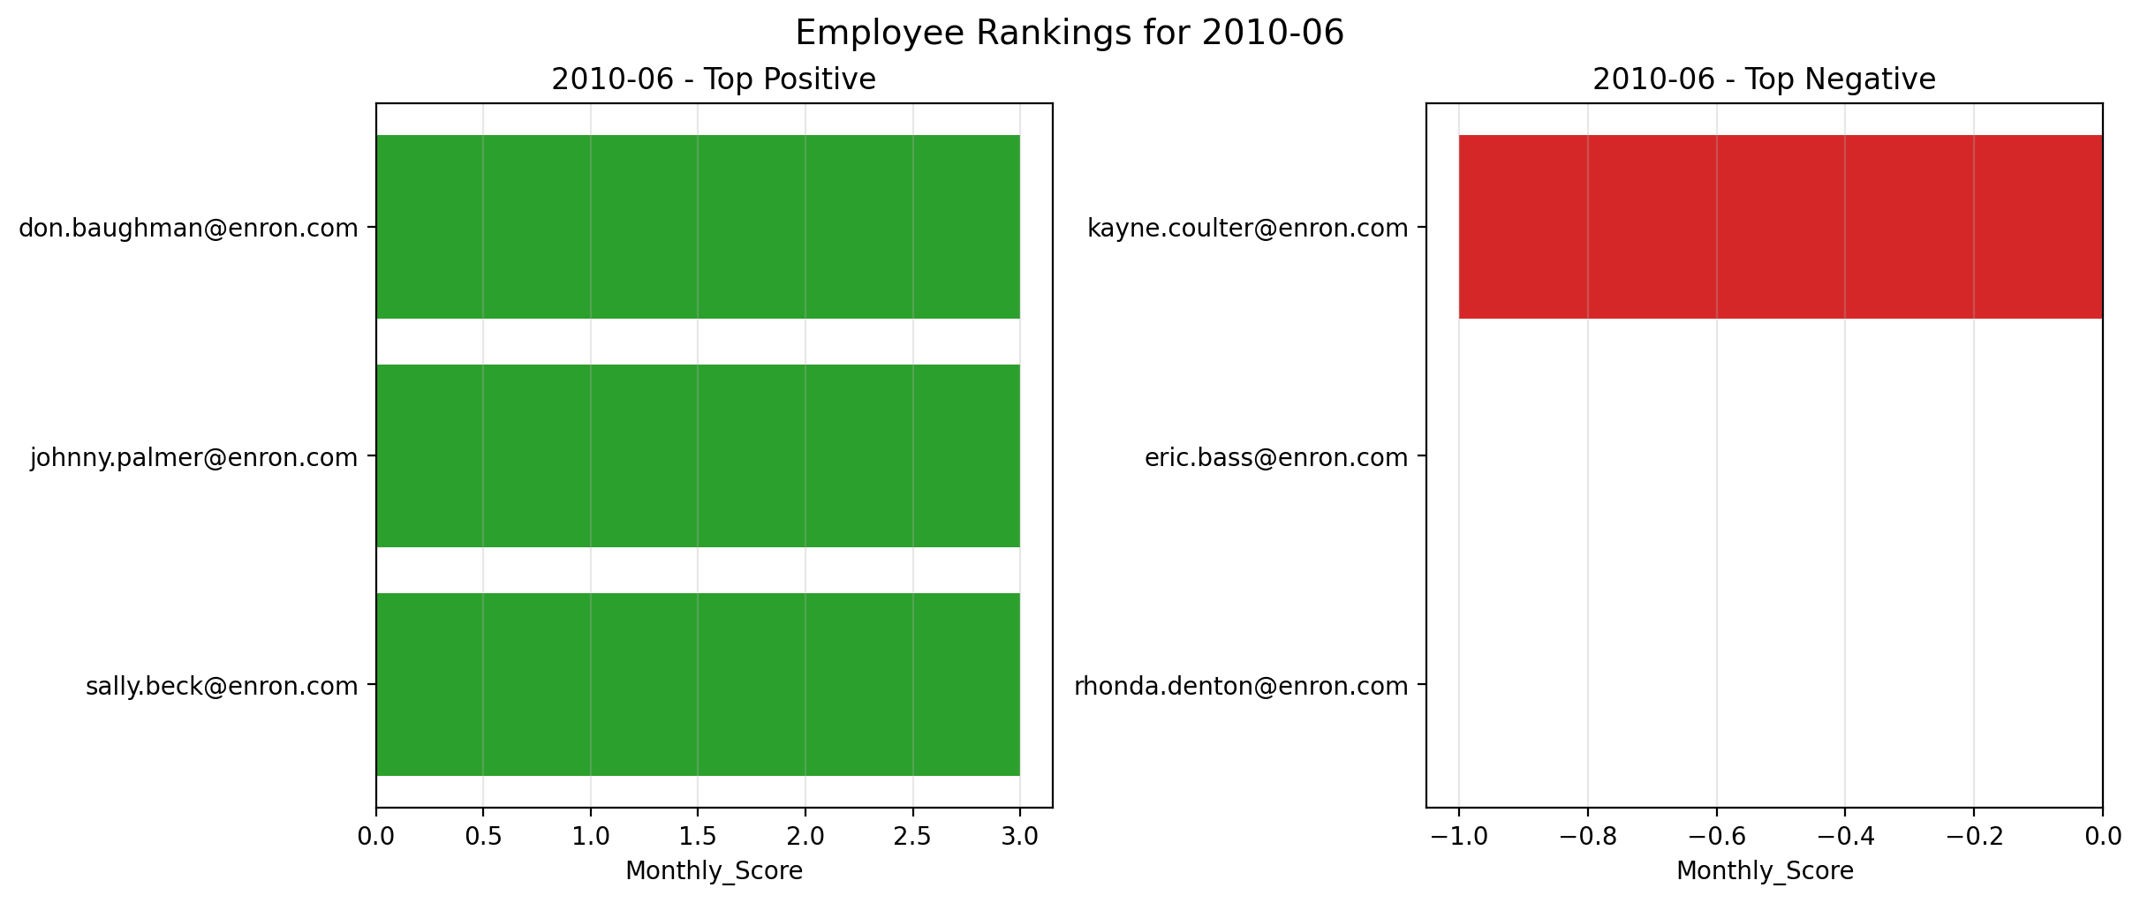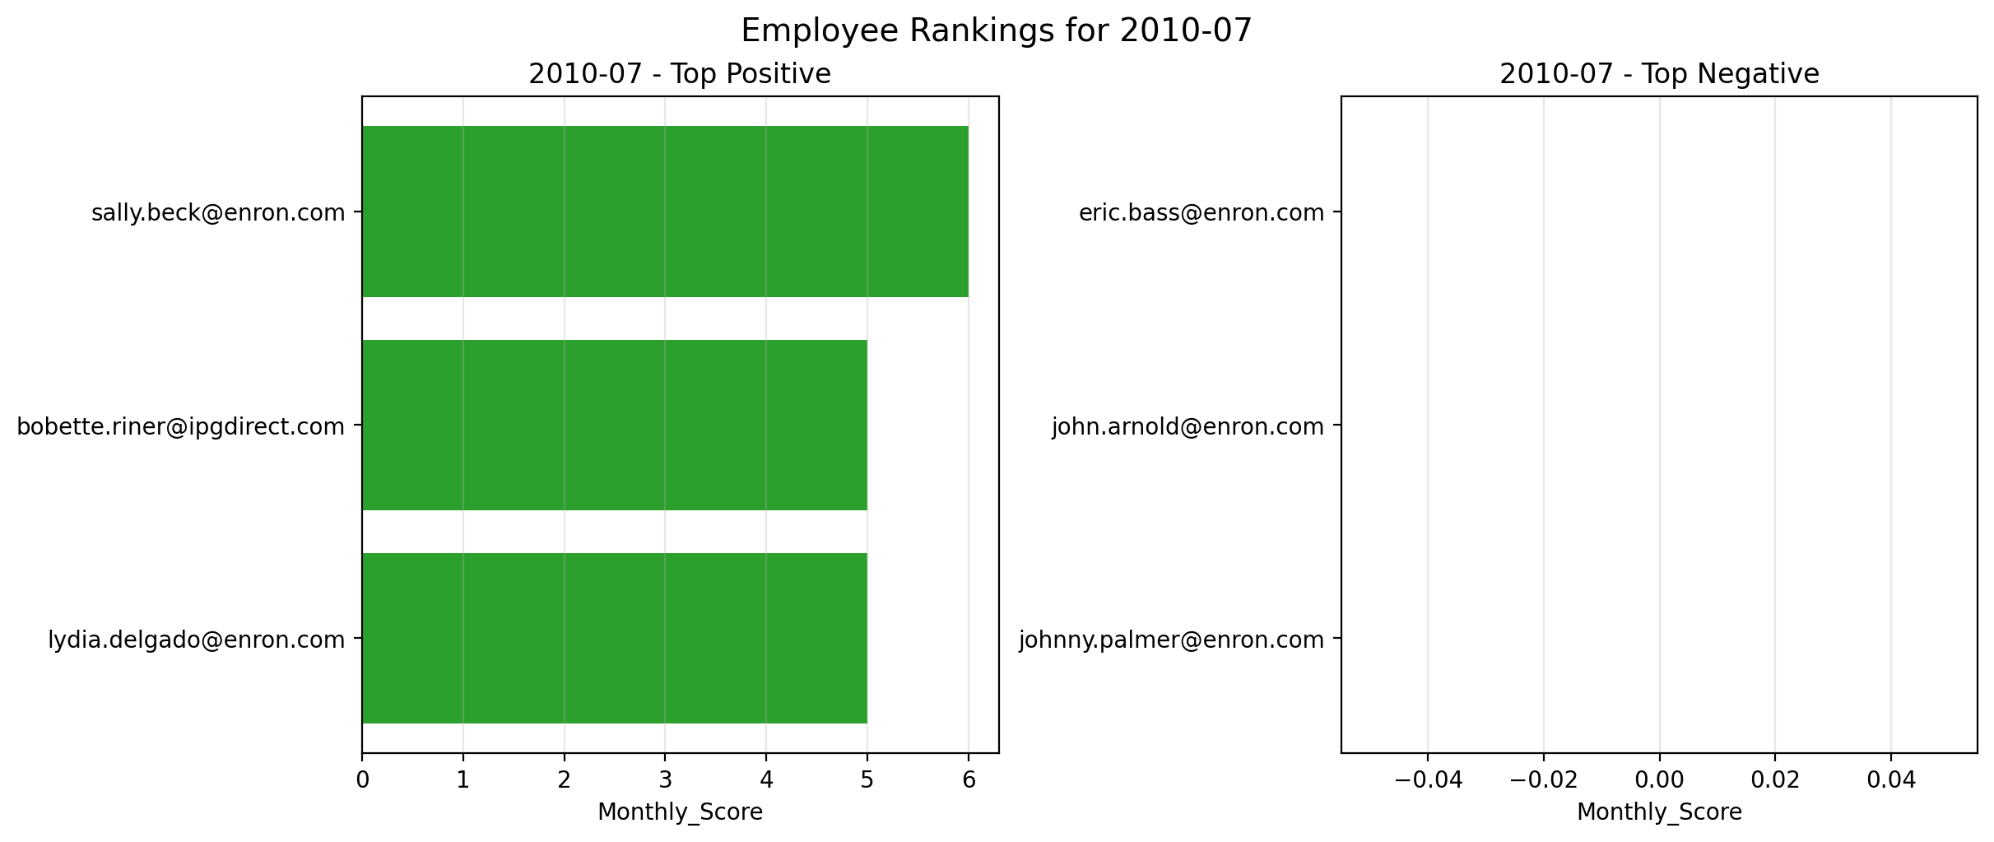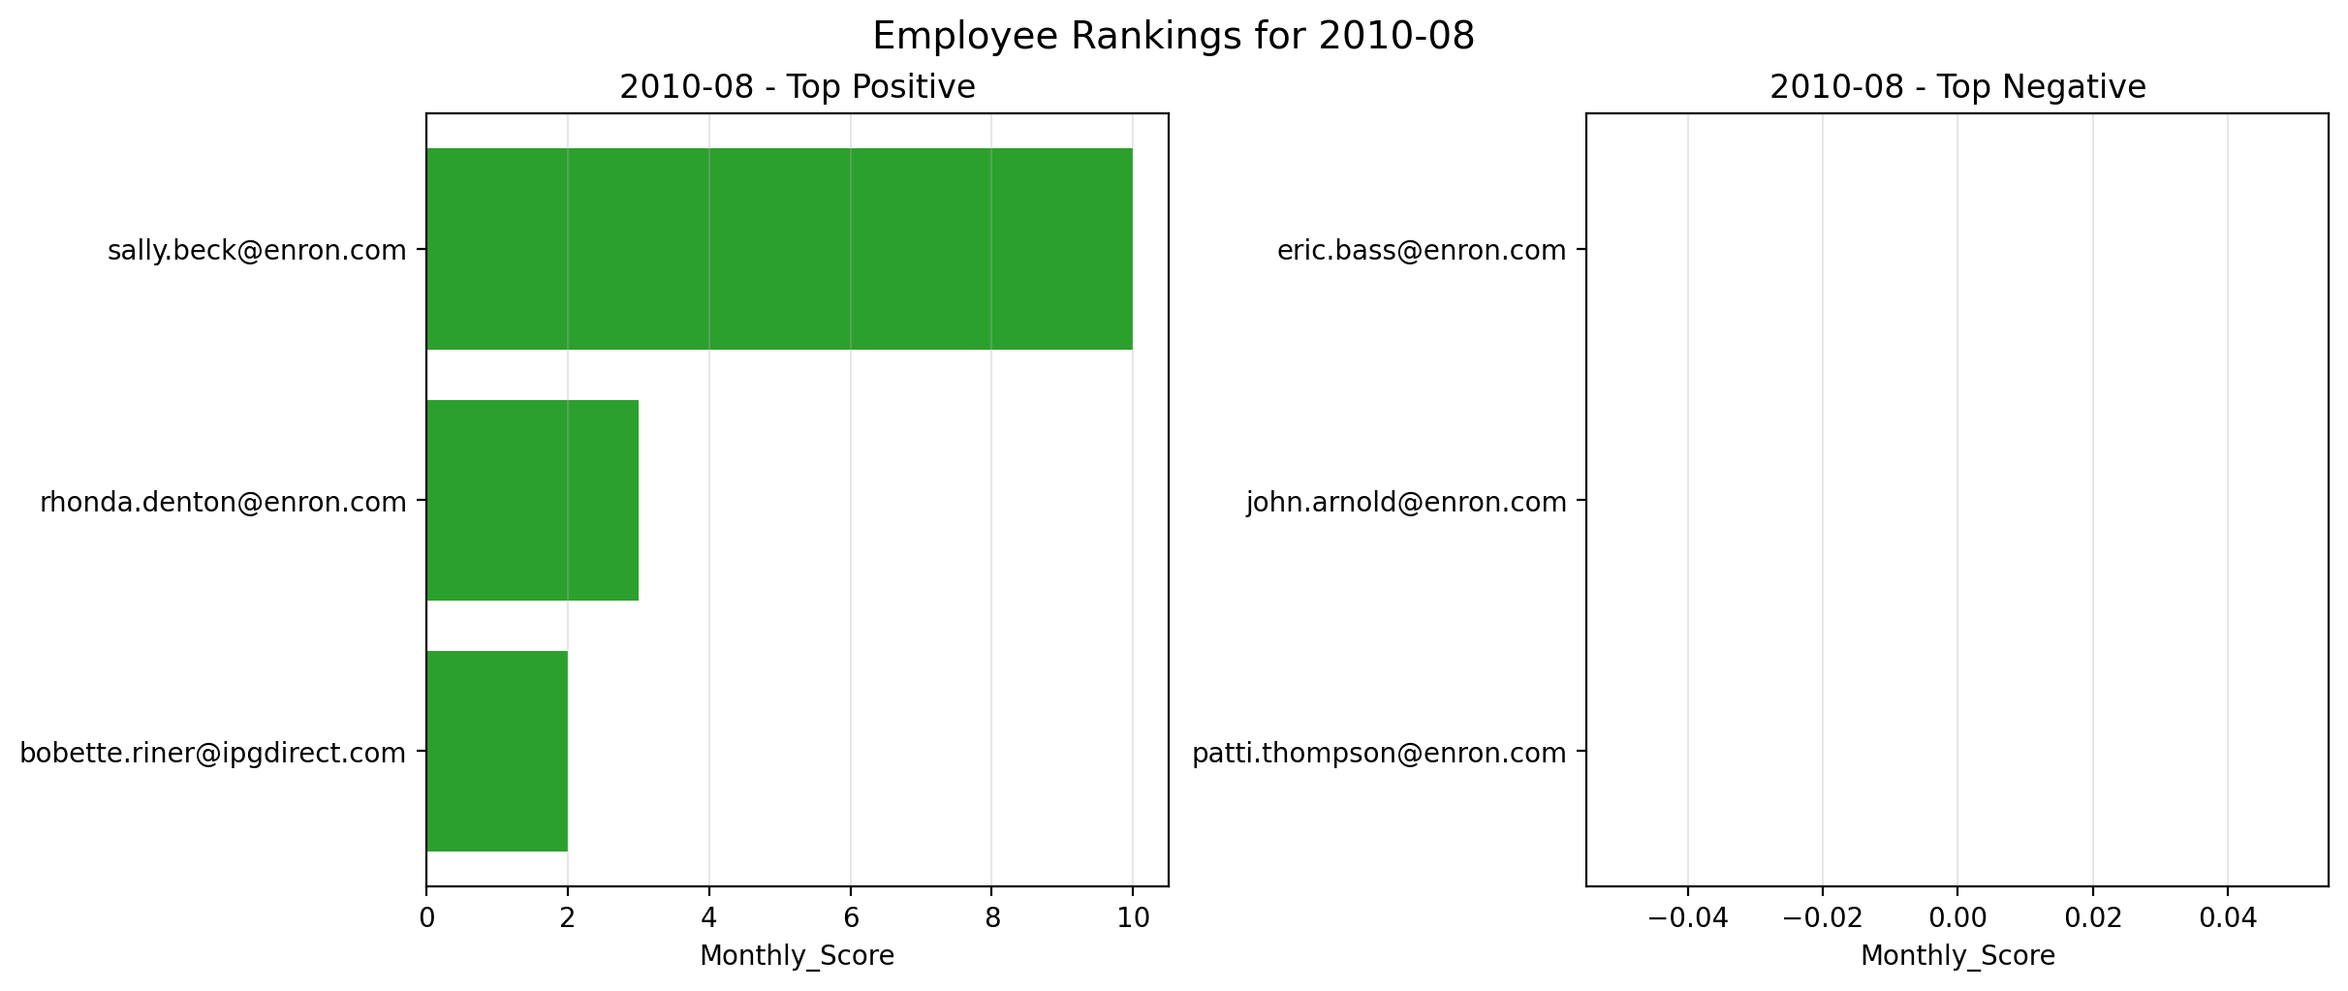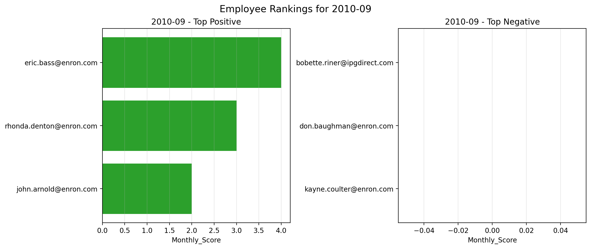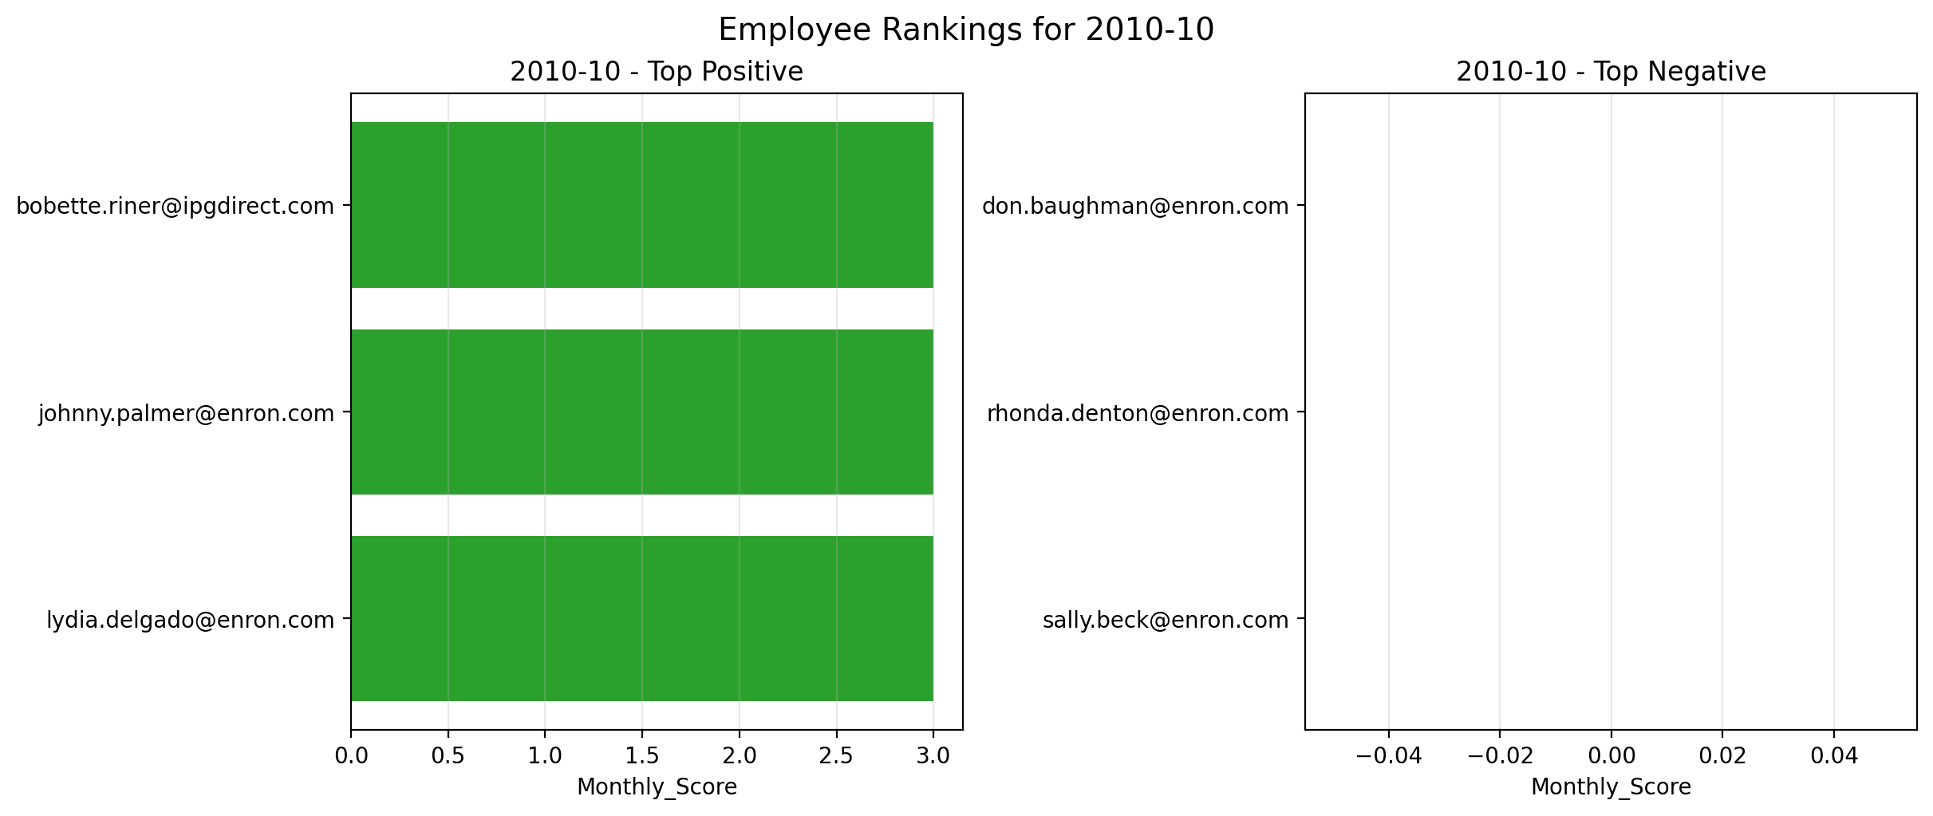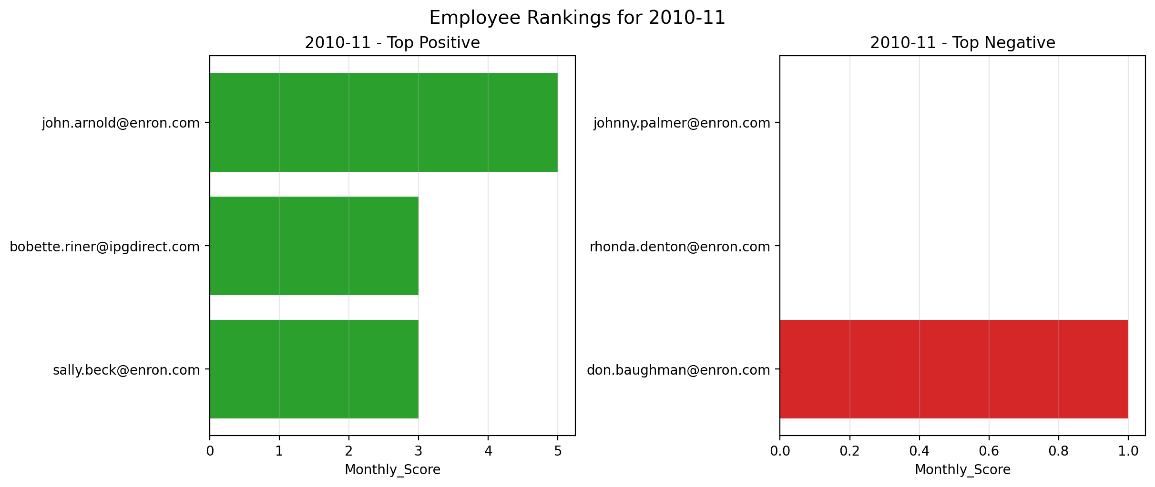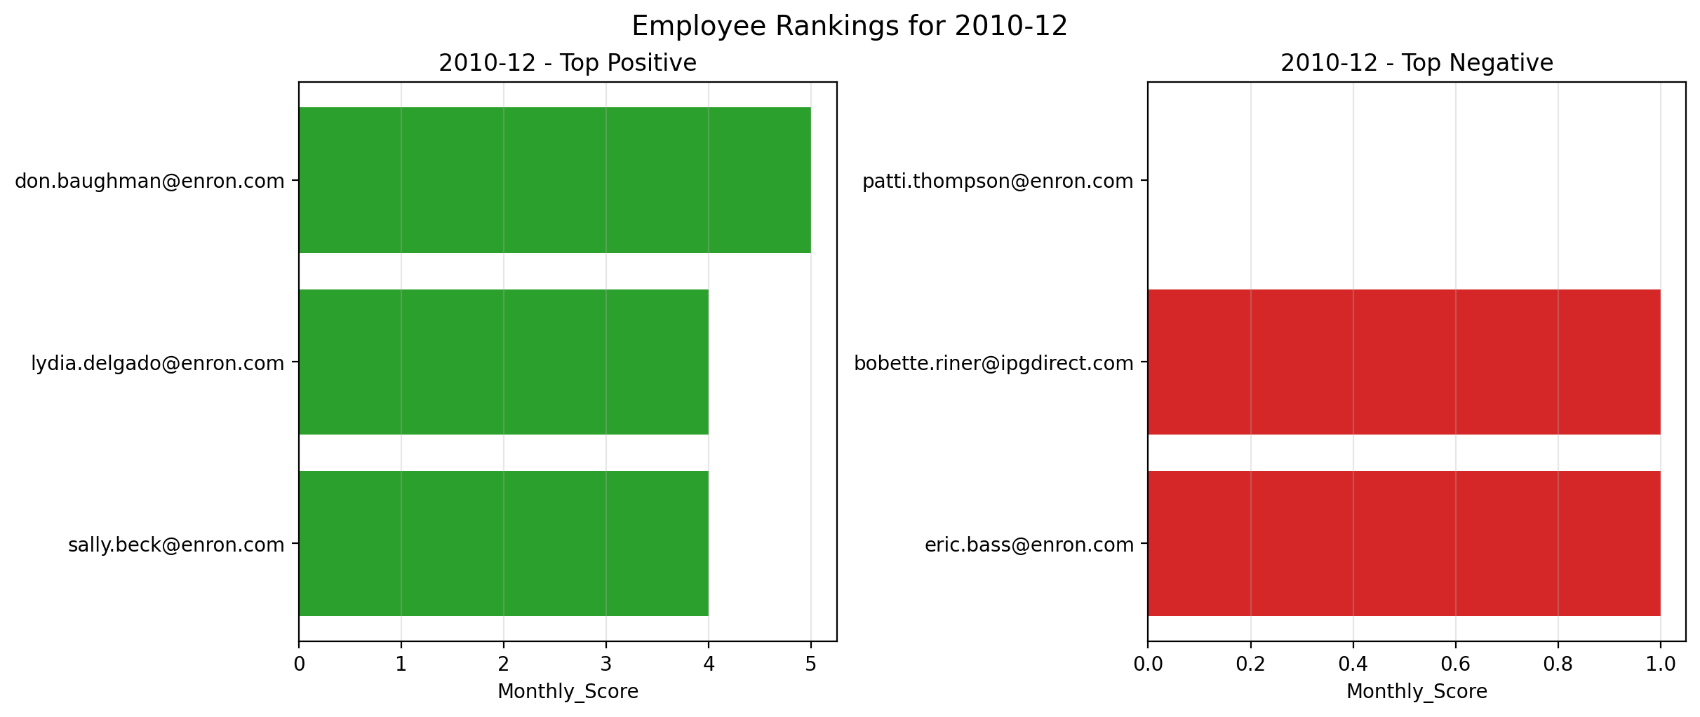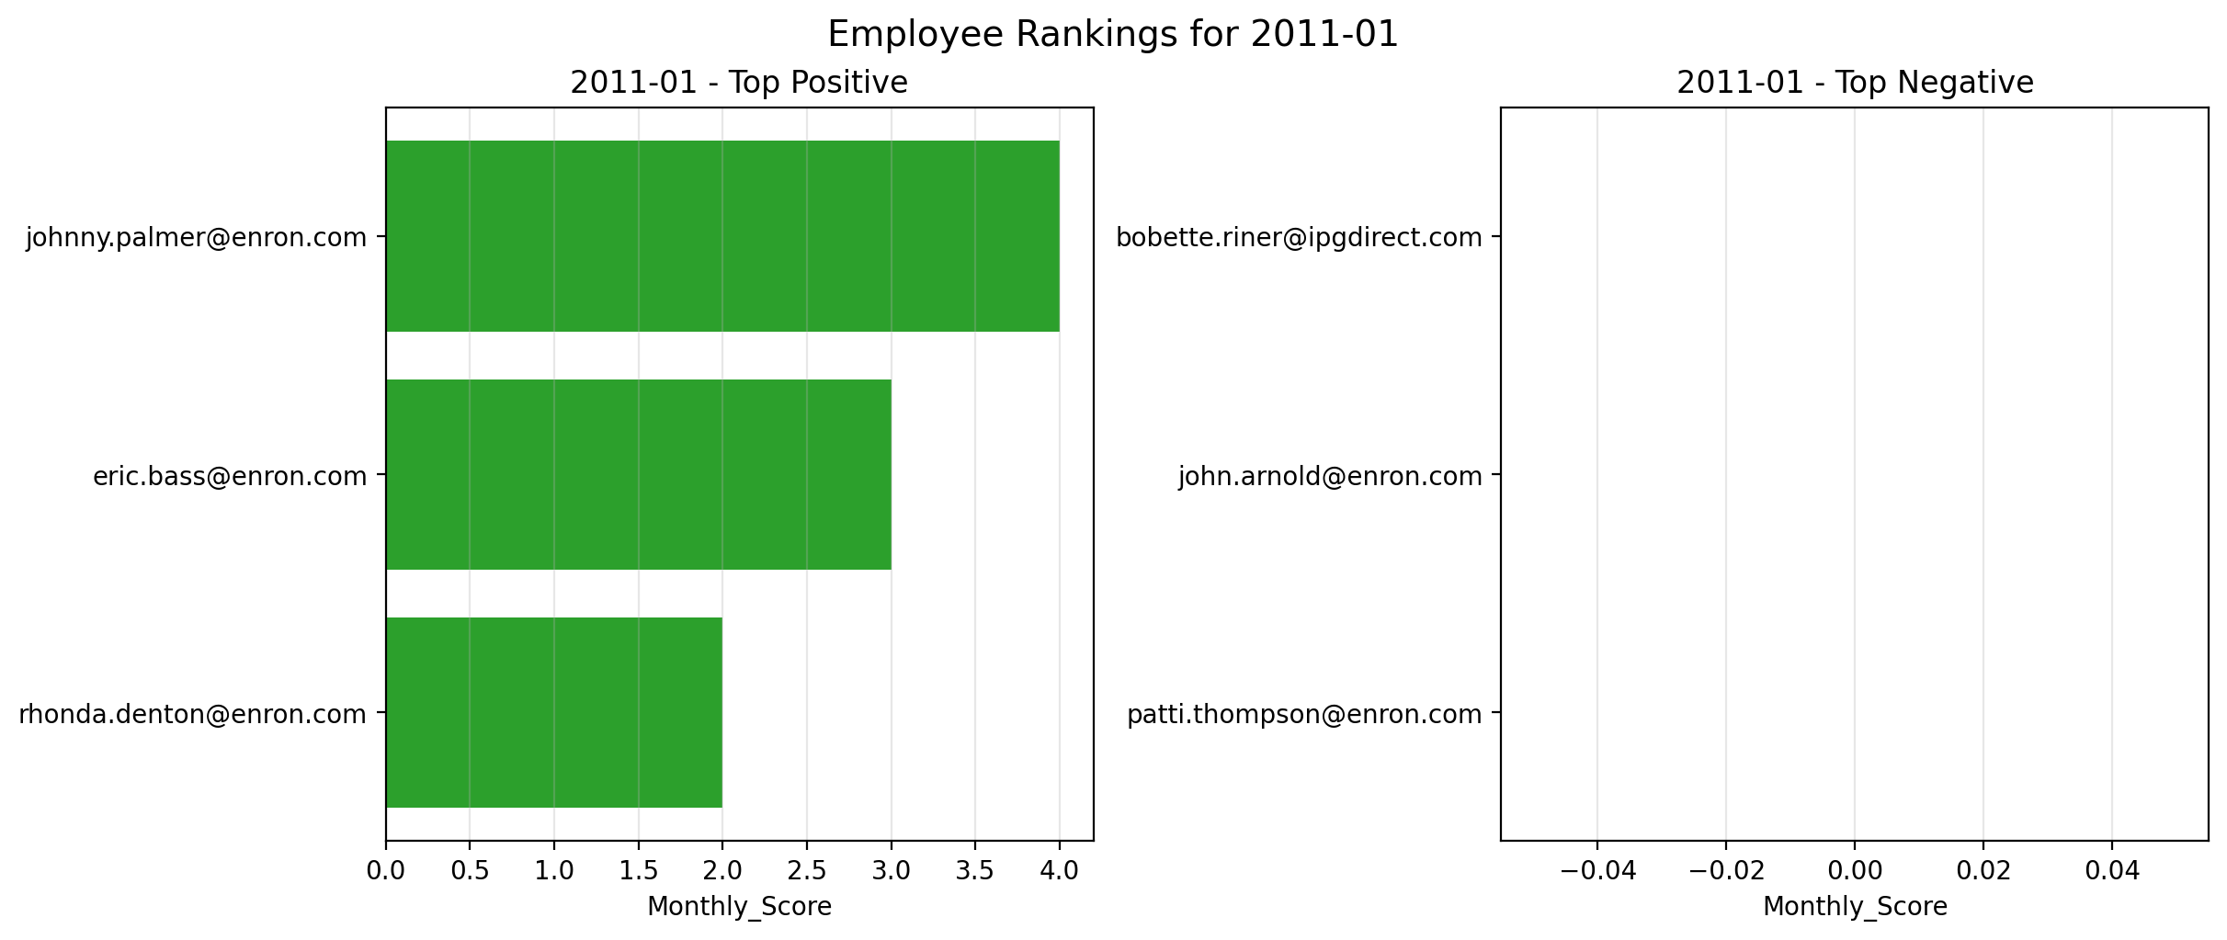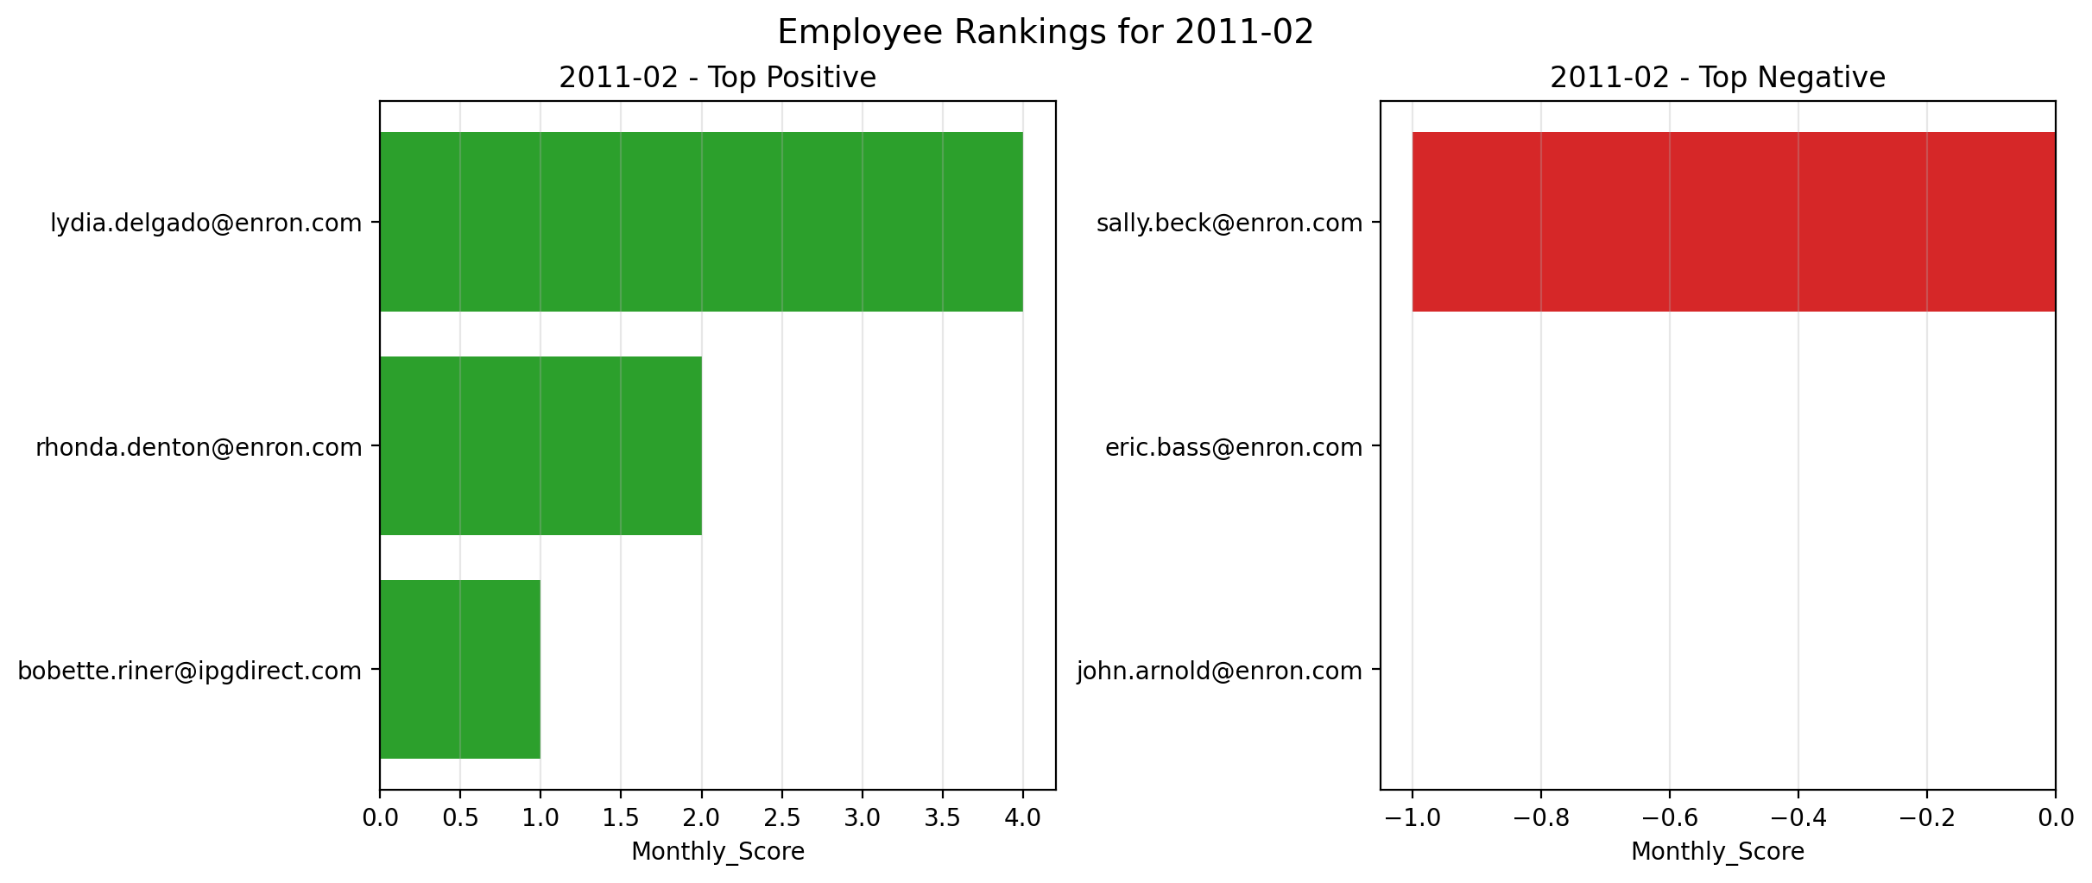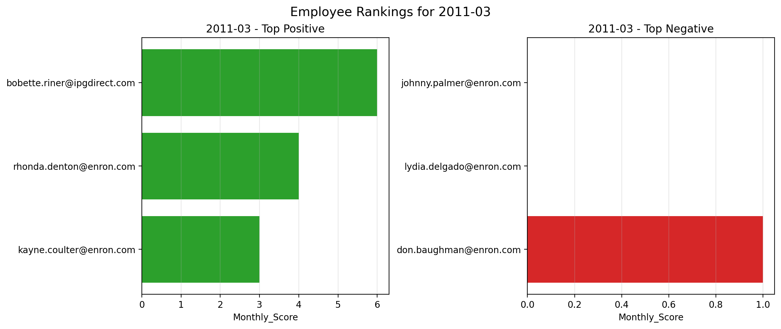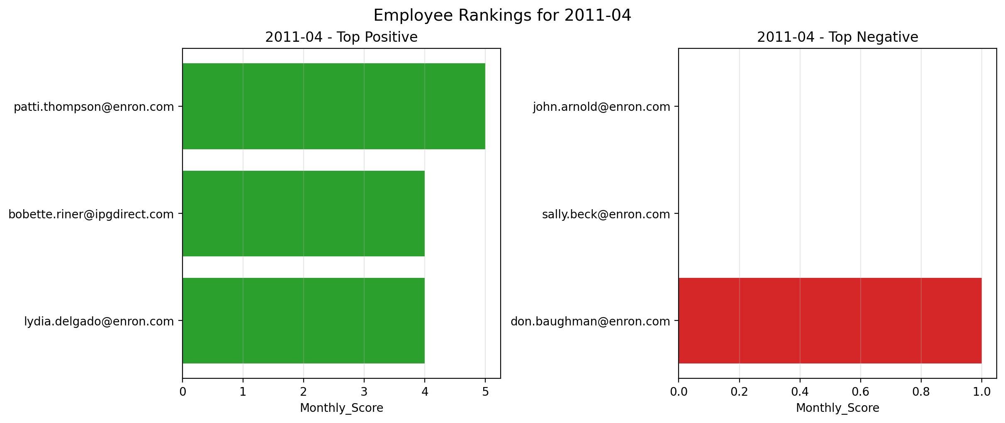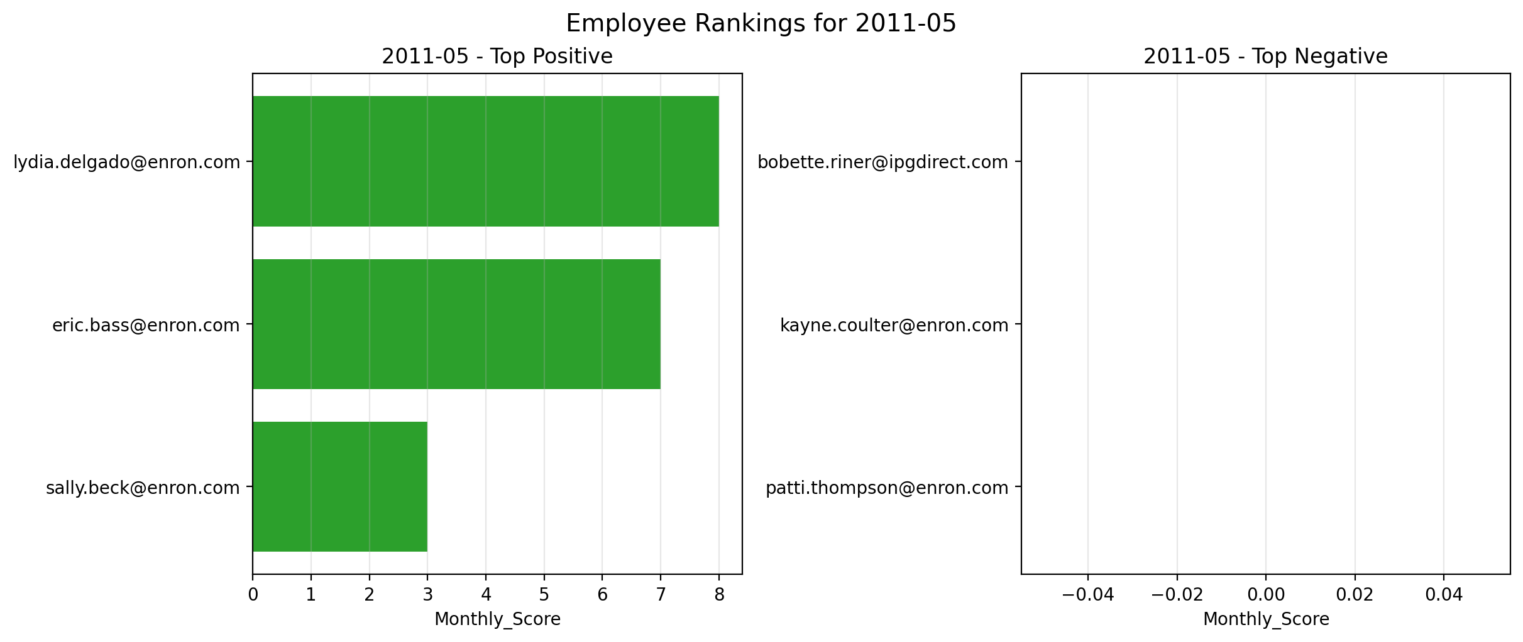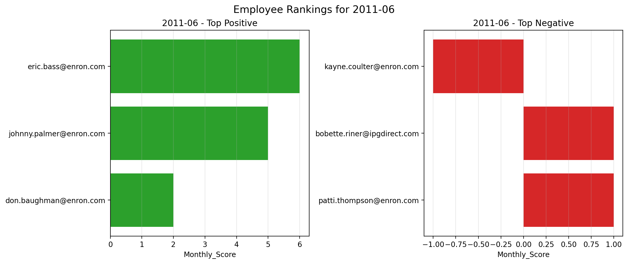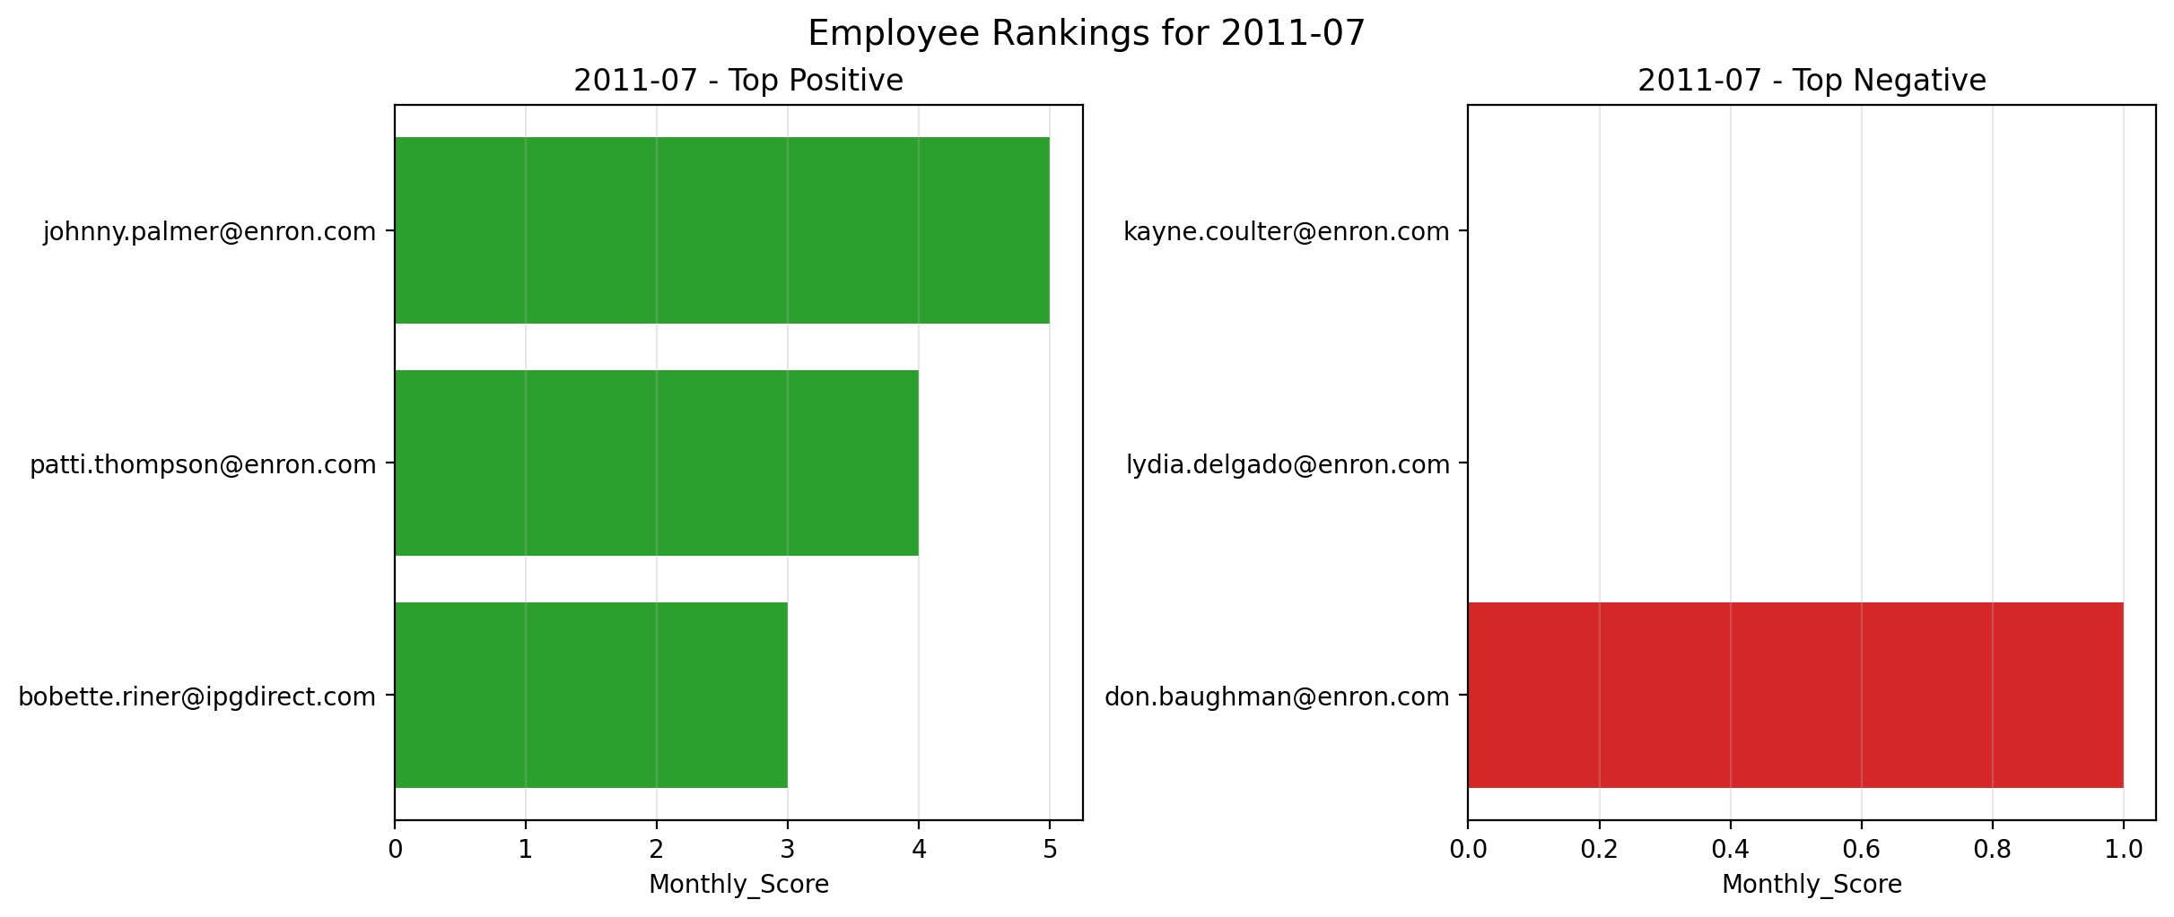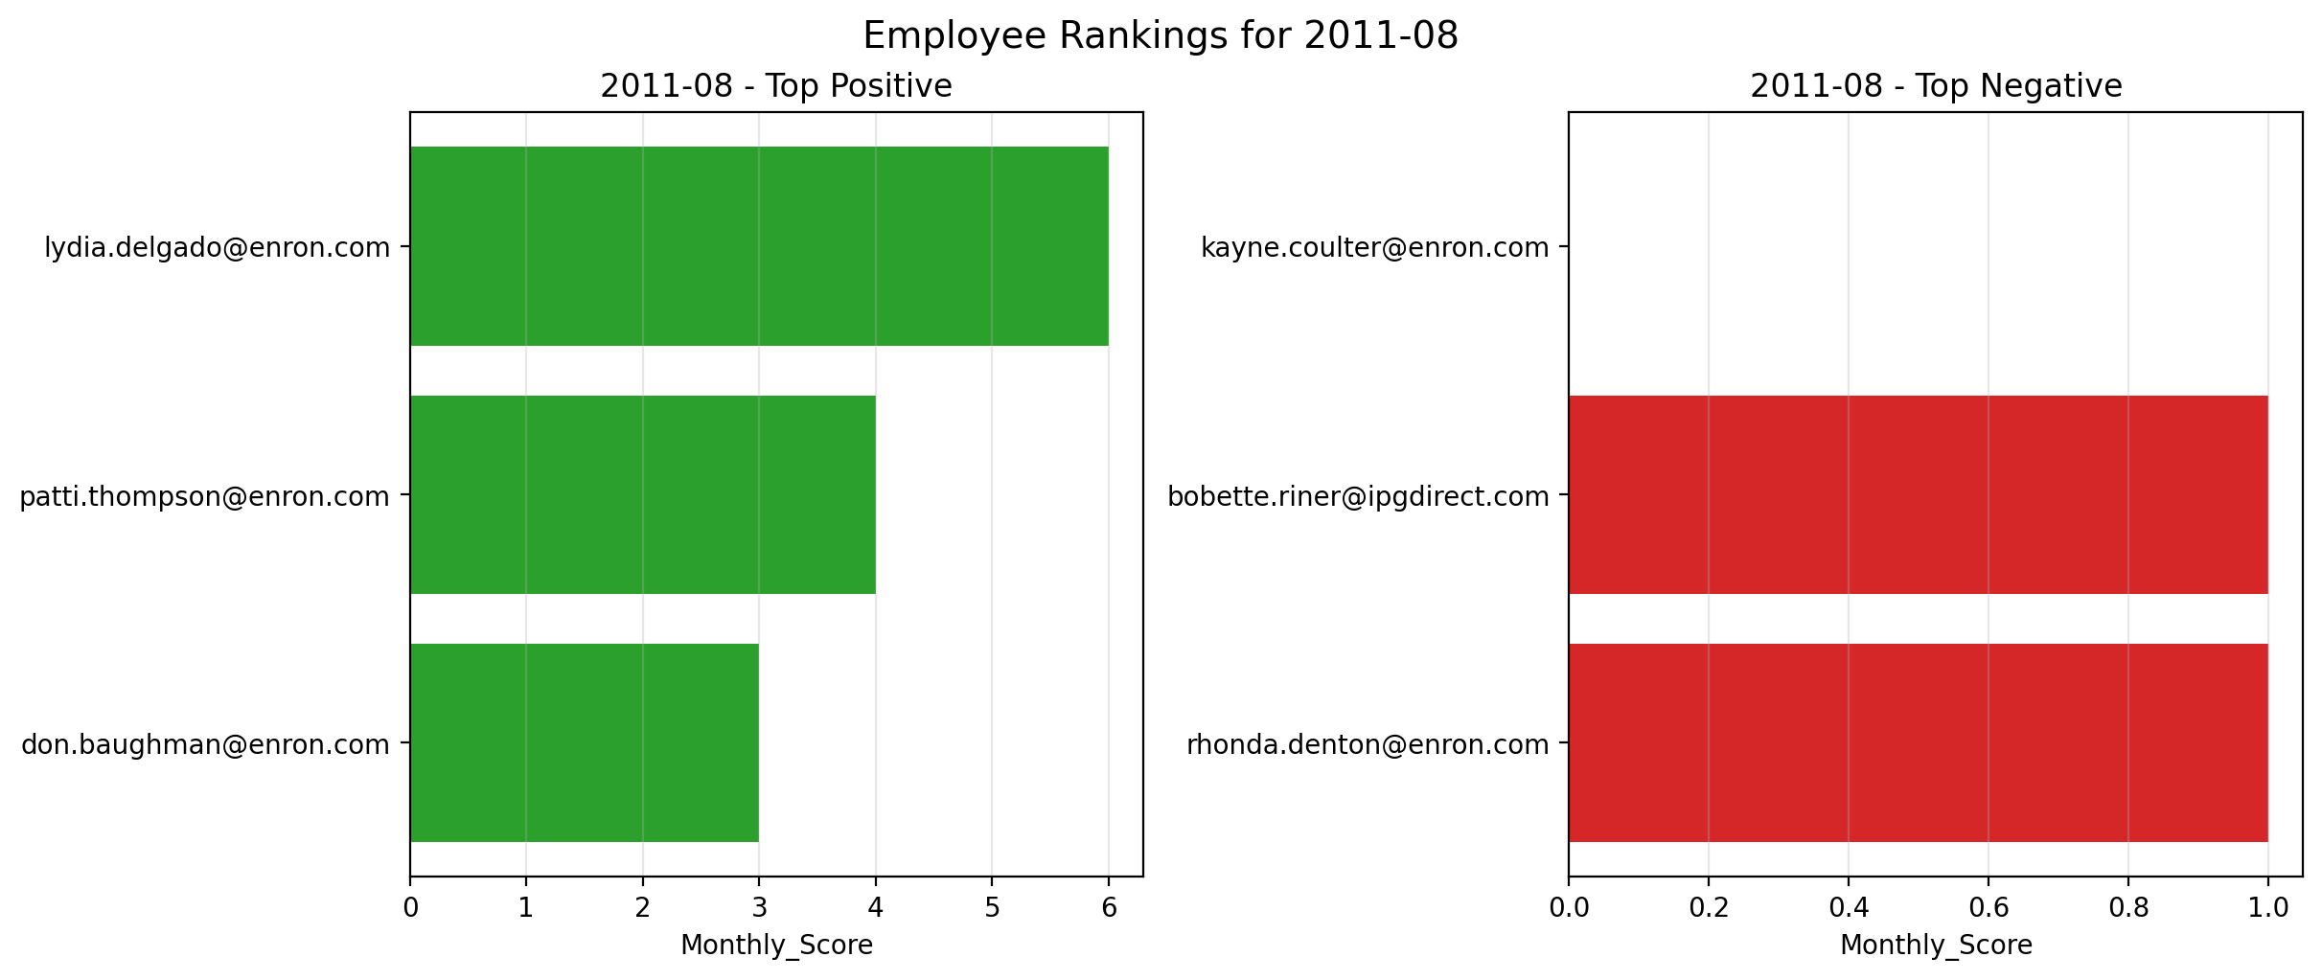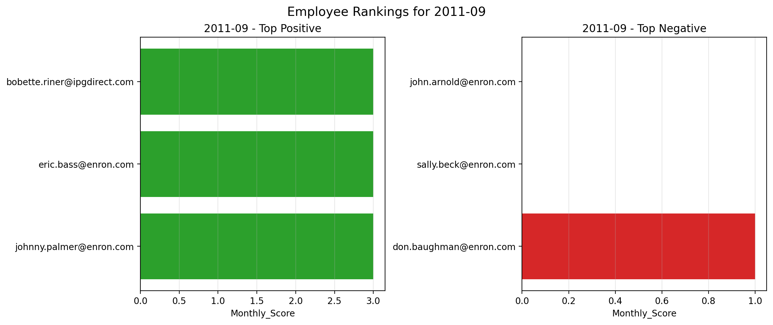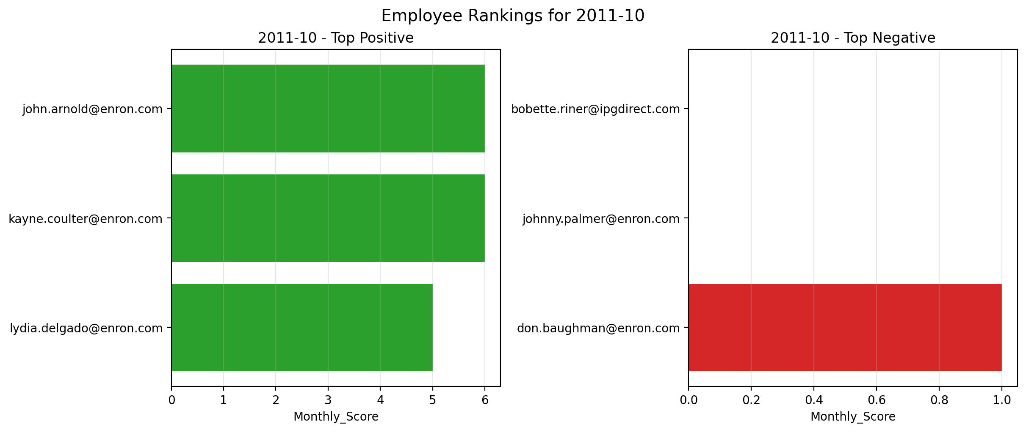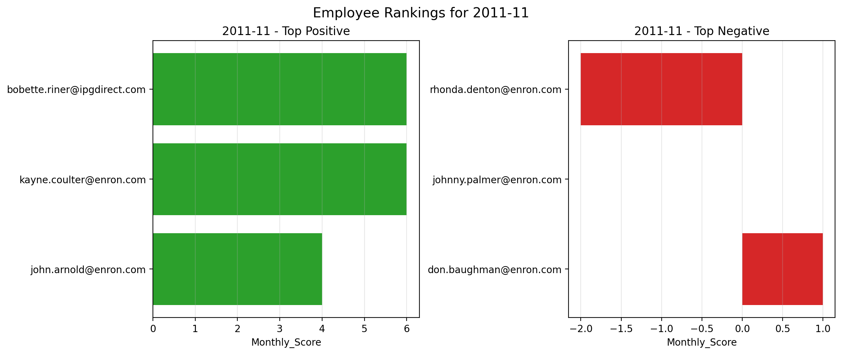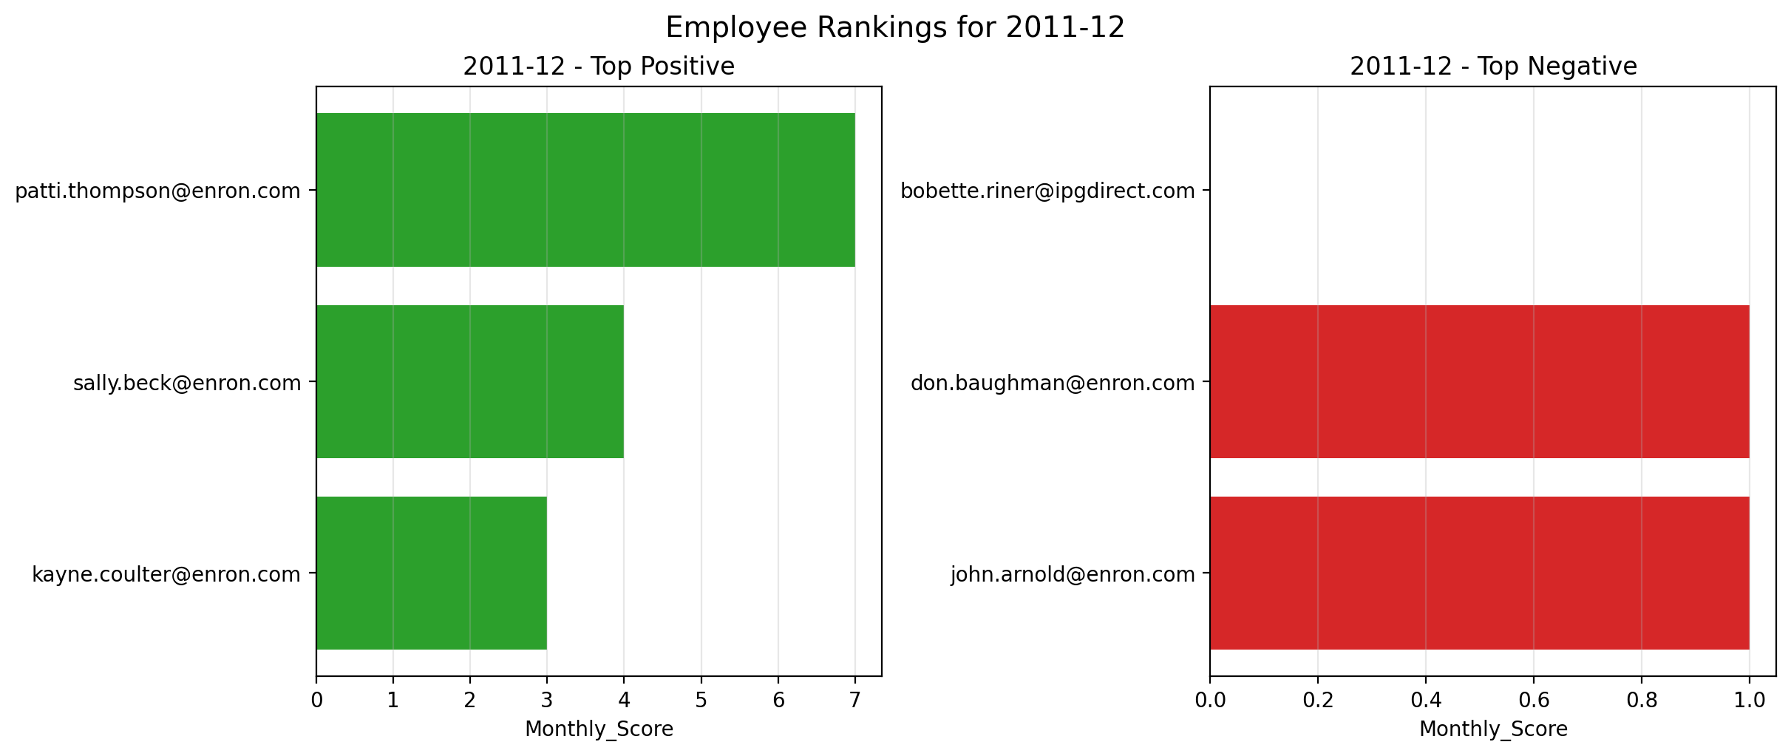
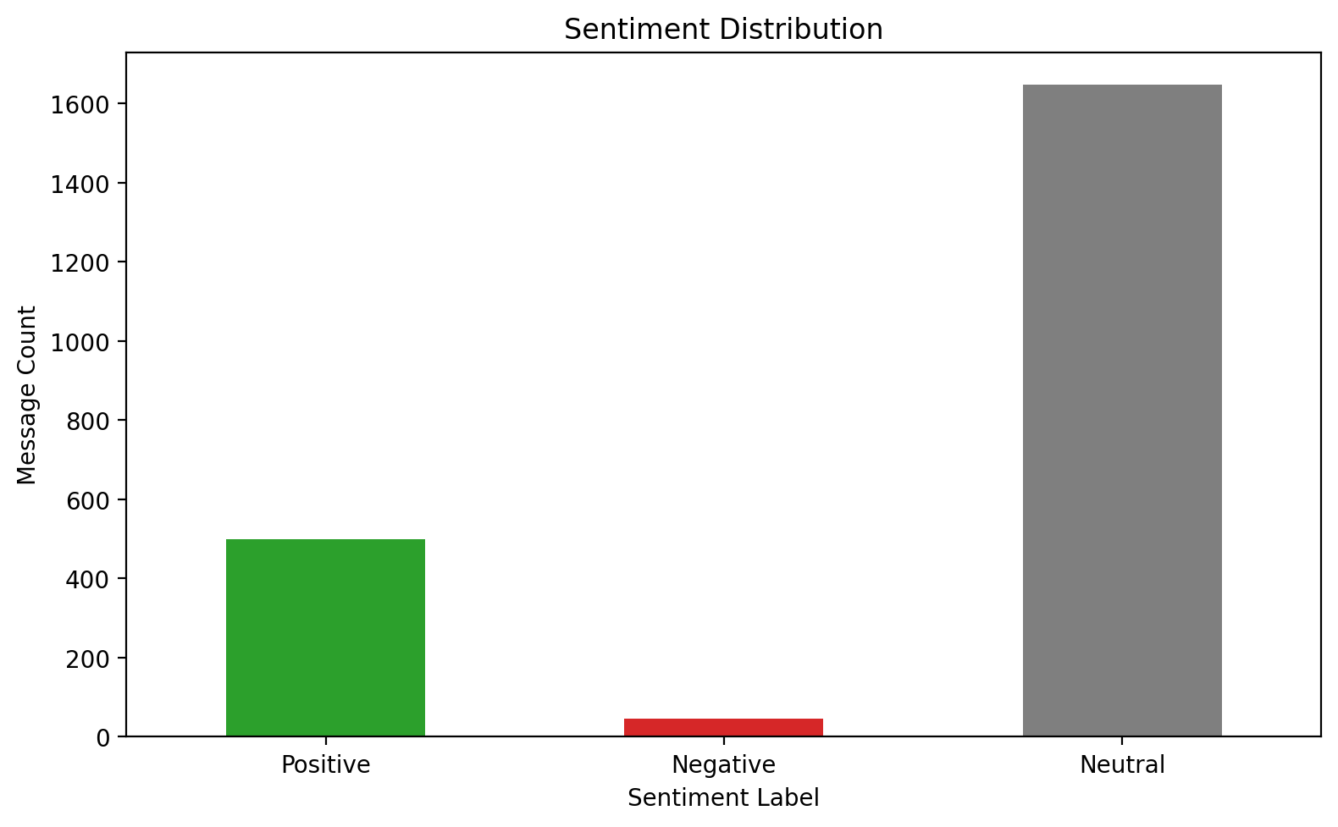
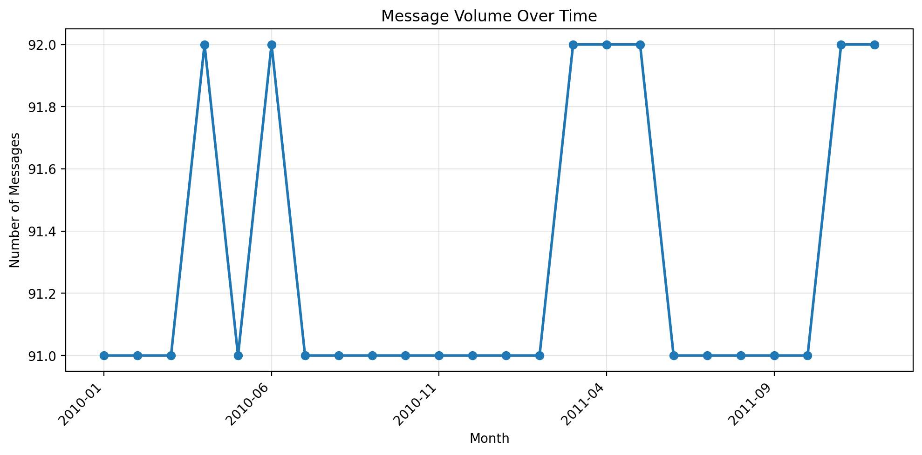
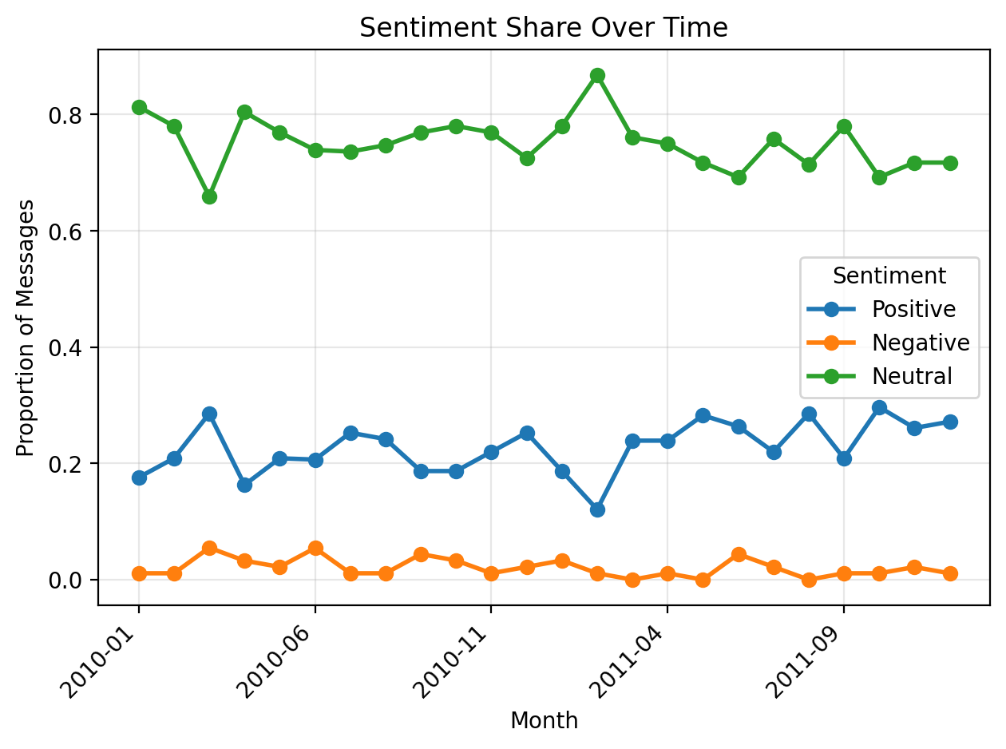
Thus we can observe that majority of the messages remained neutral showing no certain showing of positive or negative tones, employee mainly sticked to formal work talk or sometimes for non-work related messages, which were flagged as neutral.
The employee showed more positive messages between each other, while the overall proportional trend of positive messages went down slightly with time, its within limits to receive employees as positive.
The volume of message s also remains quite stable, varying between 91-92 emails per month.
Flight Risk analysis:
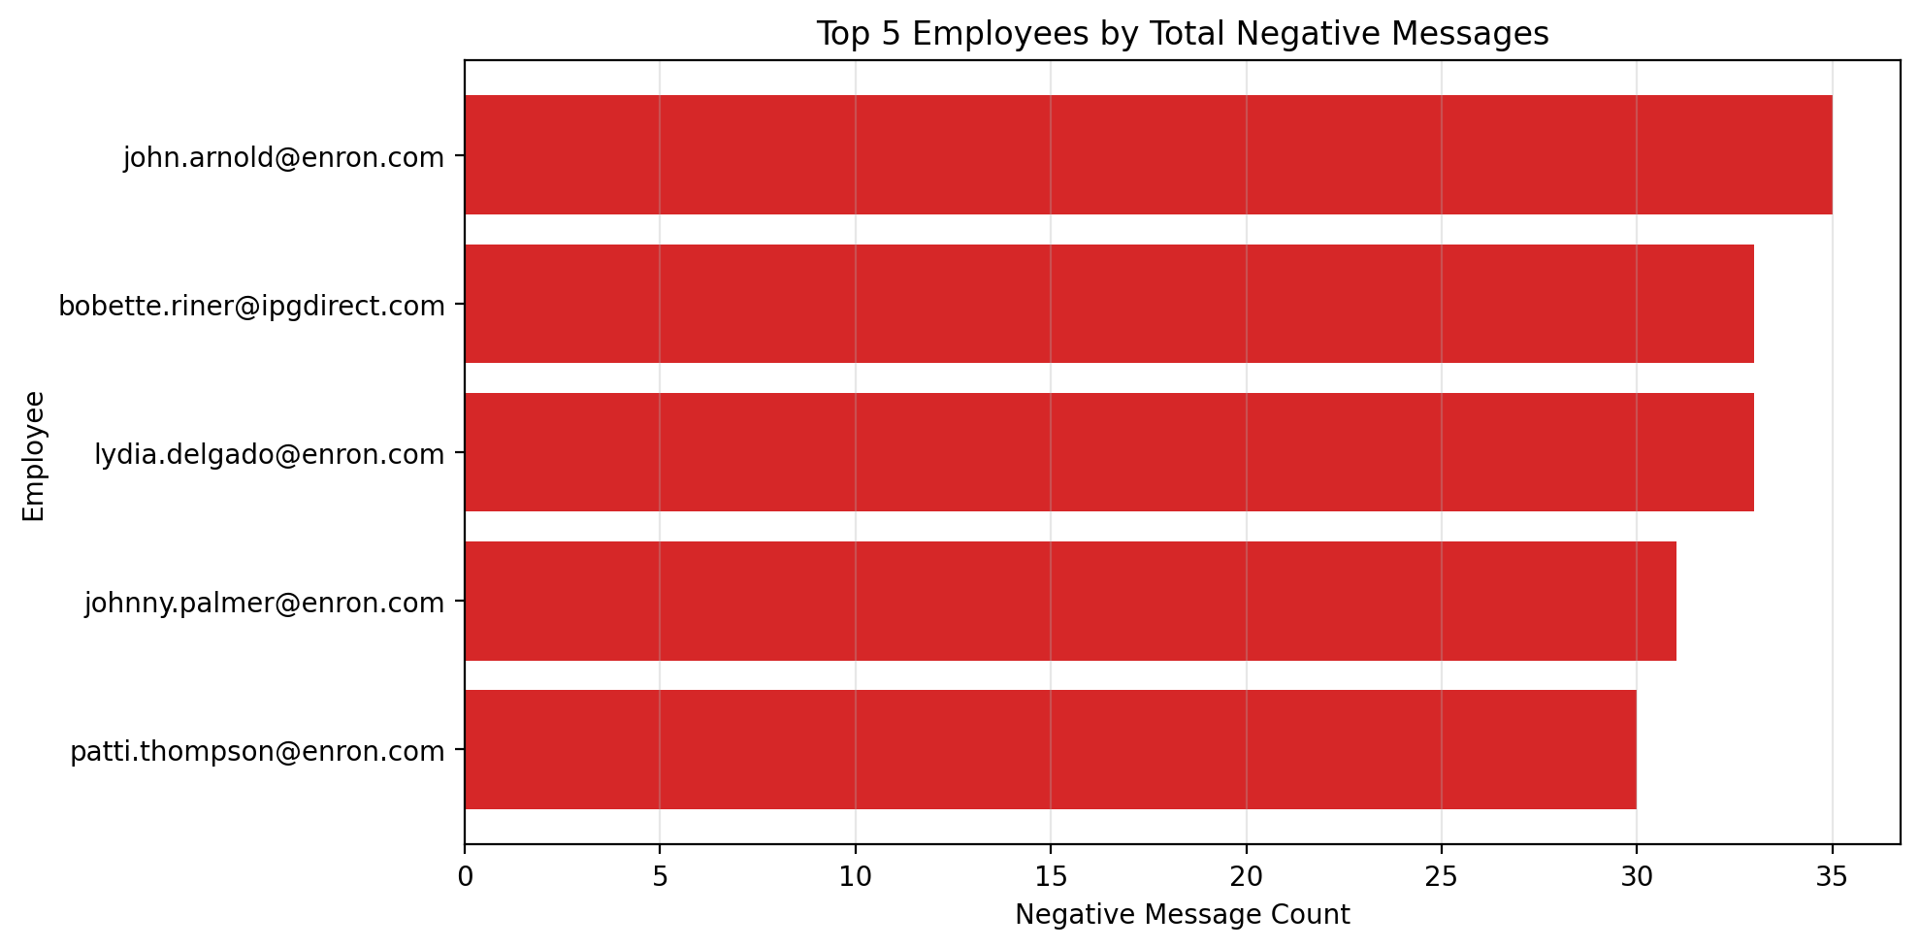
These individuals—led by John Arnold, Bobette Riner, and Lydia Delgado—persistently generate the highest volume of negative communication across the dataset. Because they consistently rank at the top of the negative message distribution month after month, their data points to a state of chronic dissatisfaction rather than a temporary, isolated spike in frustration. This sustained pattern of negative sentiment over continuous months indicates deep-rooted disengagement, making them the most critical targets for proactive retention interventions regardless of strict calendar-window boundaries.
Thus these employees are the greatest flight risks as analysed from the data.
Conclusion:
By shifting from traditional, keyword-reliant NLP to a context-aware Large Language Model framework, this project successfully overcomes the challenge of interpreting scattered and nuanced workplace communication. The persistent concentration of negative sentiment among top-ranking individuals like John Arnold over consecutive months highlights a deeper, chronic state of employee disengagement. Ultimately, this modular architecture provides leadership with the precise, reproducible, and proactive insights necessary to targetedly intervene, mitigate attrition risks, and improve overall corporate culture.

